Section 4: Pelvic Bones

Card ID: 4.1
Image file: L1344_760099
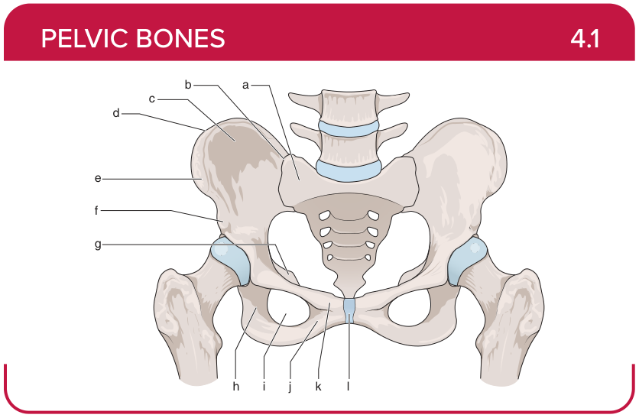
Title: Pelvic Bones (Anterior)
Activity Interaction: Drag and drop
Back-of-Card Content:
a. Sacrum
b. Sacroiliac joint
c. Iliac fossa
d. Iliac crest
e. Anterior superior iliac spine (ASIS)
f. Anterior inferior iliac spine (AIIS)
g. Ischial spine
h. Ramus of ischium
i. Obturator foramen
j. Inferior pubic ramus
k. Superior pubic ramus
l. Pubic symphysis

Card ID: 4.2
Image file: L1344_760100
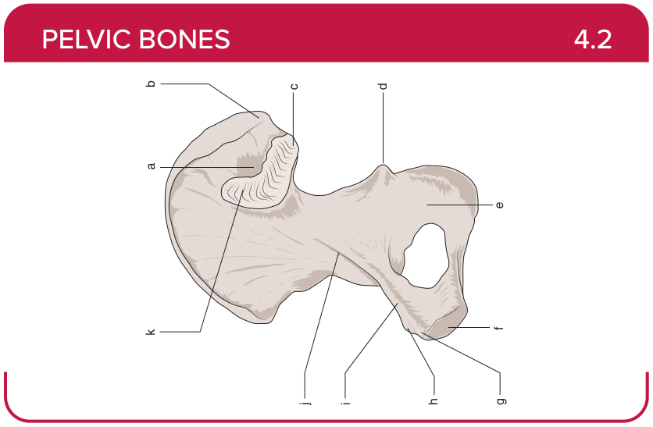
Title: Pelvic Bones (Medial)
Activity Interaction: Drag and drop
Back-of-Card Content:
a. Iliac tuberosity
b. Posterior superior iliac spine
c. Posterior inferior iliac spine
d. Ischial spine
e. Body of ischium
f. Medial end of pubis
g. Pubic crest
h. Pubic tubercle
i. Superior ramus of pubis
j. Terminal line
k. Auricular surface

Card ID: 4.3
Image file: L1344_760102
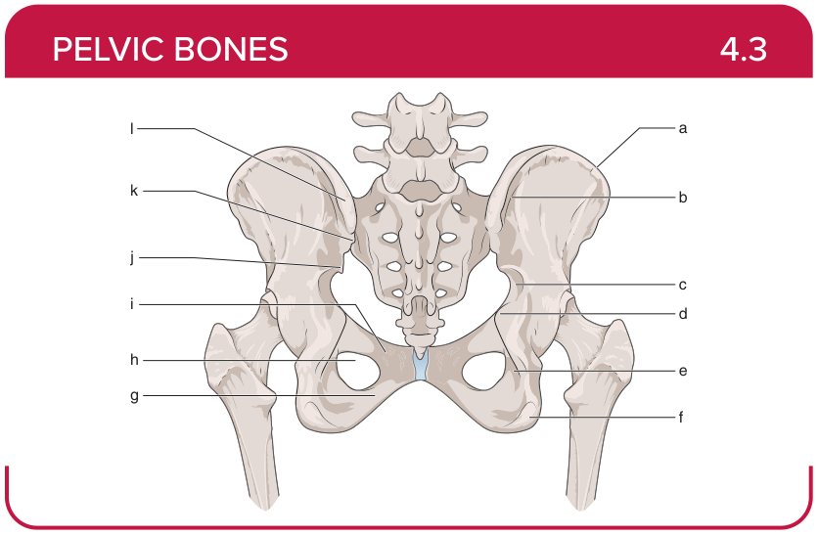
Title: Pelvic Bones (Posterior View)
Activity Interaction: Drag and drop
Back-of-Card Content:
a. Iliac crest
b. Posterior gluteal line
c. Greater sciatic notch
d. Ischial spine
e. Lesser sciatic notch
f. Ischial tuberosity
g. Inferior pubic ramus
h. Obturator foramen
i. Superior pubic ramus
j. Posterior inferior iliac spine
k. Posterior superior iliac spine
l. Iliac tuberosity

Card ID: 4.4
Image file: L1344_760103
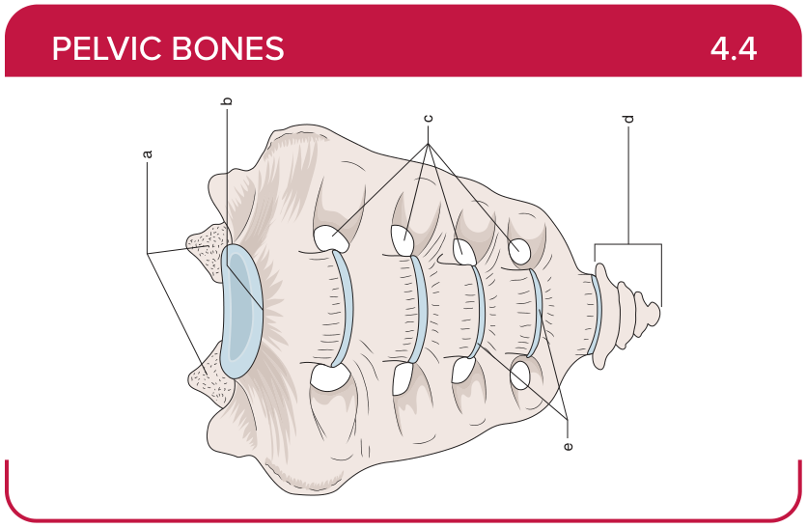
Title: Sacrum
Activity Interaction: Drag and drop
Back-of-Card Content:
a. Superior articular processes
b. Sacral promontory
c. Sacral foramina
d. Coccyx
e. Transverse lines

Card ID: 4.5
Image file: L1344_760104
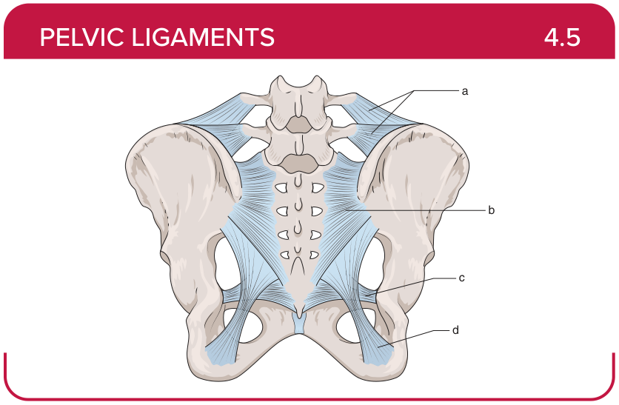
Title: Posterior Ligaments
Activity Interaction: fill-in-the-blank
Back-of-Card Content:
a. Iliolumbar ligaments: restricts excessive side bending and rotation of the lumbar spine, anterior shear forces between L5 and the sacrum
b. Posterior sacroiliac ligament: restricts displacement of the ilium from the sacrum
c. Sacrospinous ligament: restricts excessive rotation of the pelvis and sacrum
d. Sacrotuberous ligament: restricts excessive anterior tipping of the sacrum

Card ID: 4.6
Image file: L1344_760105
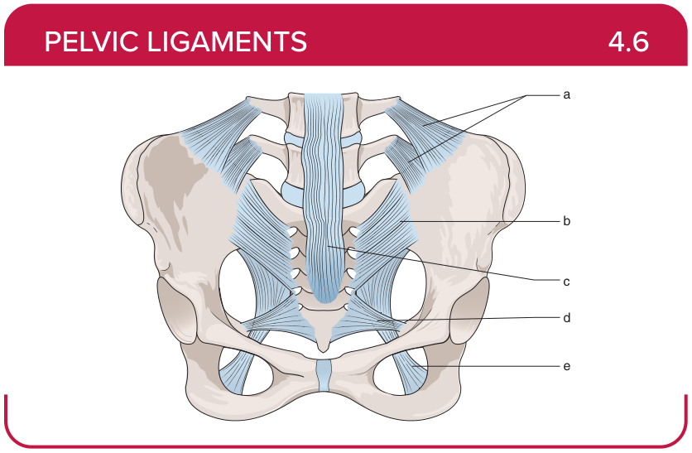
Title: Anterior Ligaments
Activity Interaction: fill-in-the-blank
Back-of-Card Content:
a. Iliolumbar ligaments: restricts excessive side bending and rotation of the lumbar spine, anterior shear forces between L5 and the sacrum
b. Anterior sacroiliac ligament: minimal impact on pelvic stability, connects the anterior sacrum to the ilium
c. Anterior longitudinal ligament: restricts excessive extension, reinforces intervertebral discs
d. Sacrospinous ligament: restricts excessive rotation of the pelvis and sacrum
e. Sacrotuberous ligament: restricts excessive anterior tipping of the sacrum

Card ID: 4.7
Image file: L1344_760106
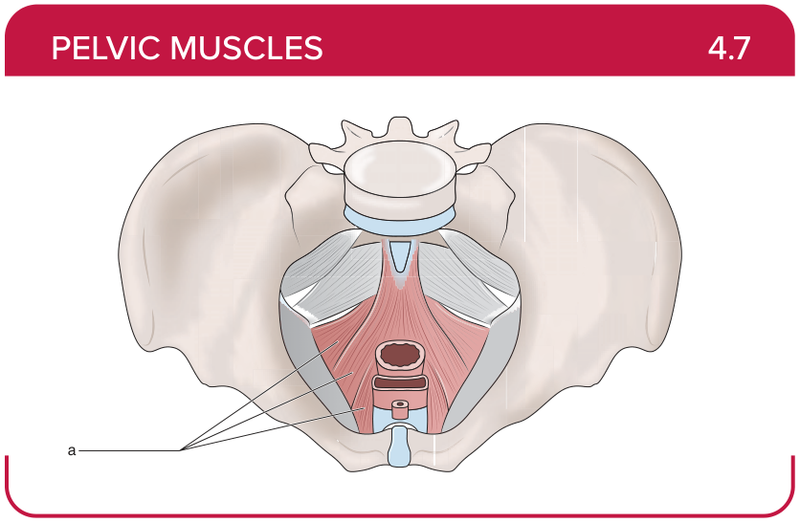
Title: Levator ani (iliococcygeus, puborectalis, pubococcygeus)
Activity Interaction: select all that apply
Back-of-Card Content:
Proximal insertion:
- *pubis
- *ischium
- anococcygeal ligament

Distal insertion:
- *urethra
- *anal canal
- *perineal body
- *coccyx
Innervation:
- *pudendal nerve
- anterior rami of spinal nerves S4-S5

Action:
- *compression of the anal canal
- *defecation, urination, birth
- *coughing

Card ID: 4.8
Image file: L1344_760107
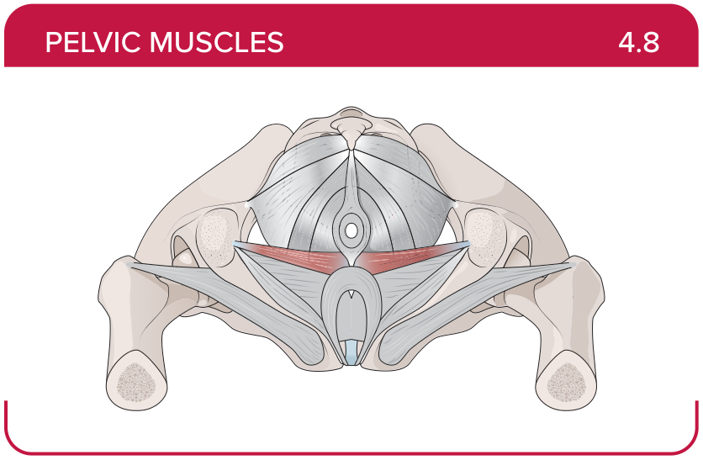
Title: Superficial transverse perineal
Activity Interaction: select all that apply
Back-of-Card Content:
Proximal insertion:
- *ischium
- pubis
- anococcygeal ligament

Distal insertion:
- *perineal body
- pubic symphysis
- coccyx
Innervation:
- *pudendal nerve
- anterior rami of spinal nerves S4-S5

Action:
- *supports the perineal body
- *maintains the anus at the center of the perineum
- compression of the anal canal

Card ID: 4.9
Image file: L1344_760108
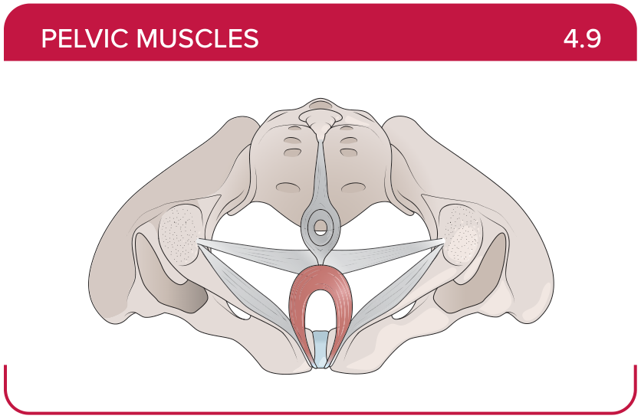
Title: Bulbospongiosus
Activity Interaction: select all that apply
Back-of-Card Content:
Proximal insertion:
- *perineal body
- anococcygeal ligament
- ischial rami

Distal insertion:
- *perineal membrane
- *corpus spongiosum of the penis, deep fascia of the penis, clitoris in the female
- pubic symphysis

Innervation:
- *pudendal nerve
- anterior rami of spinal nerves S4-S5

Action:
- *compresses the urethra during urination or ejaculation
- *aids erection
- stabilizes the coccyx

Card ID: 4.10
Image file: L1344_760109
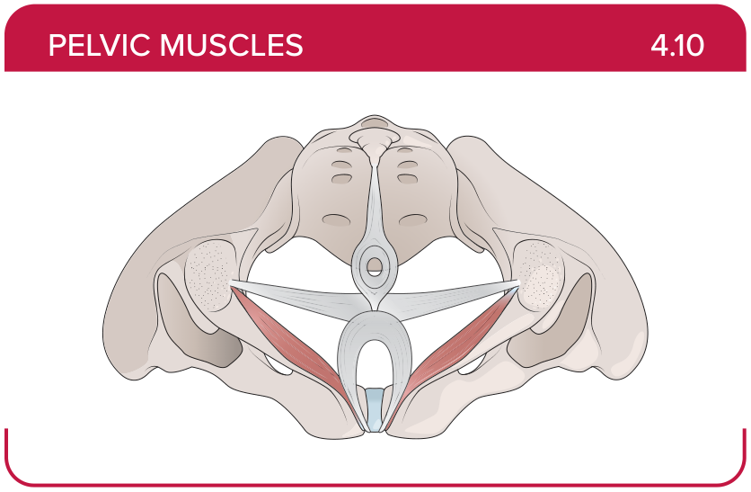
Title: Ischiocavernosus
Activity Interaction: select all that apply
Back-of-Card Content:
Proximal insertion:
- *ischium
- *ischial rami
- *pubic rami
Distal insertion:
- *pubic symphysis
- *corpus cavernosum of the penis in males, clitoris in females
- perineal body

Innervation:
- *pudendal nerve
- anterior rami of spinal nerves S4-S5

Action:
- *compresses veins to maintain erection
- supports the pelvic floor
- closes the anus

Card ID: 4.11
Image file: L1344_760110
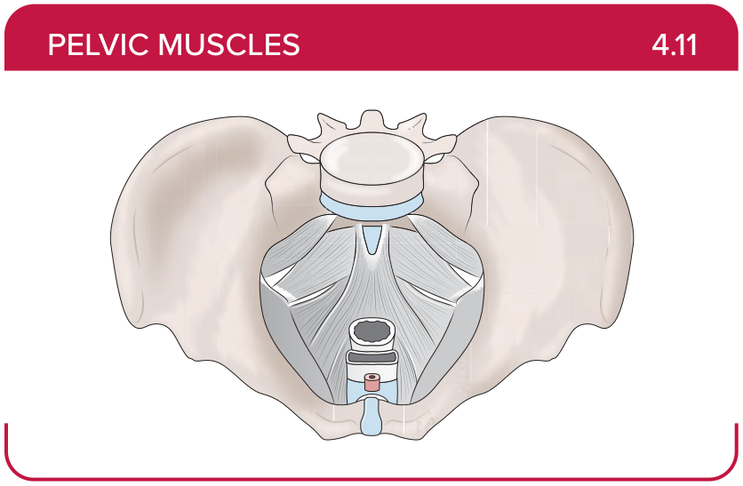
Title: External urethral sphincter
Activity Interaction: select all that apply
Back-of-Card Content:
Proximal insertion:
- *ischial rami
- *pubic rami
- pubic symphysis
- ischial spine

Distal insertion:
- *male—median raphe; female—vaginal wall
- perineal body
- coccyx

Innervation:
*pudendal nerve
anterior rami of spinal nerves S4-S5

Action:
- *voluntarily compresses urethra during urination
- closes the anus
- stabilizes the coccyx

Card ID: 4.12
Image file: L1344_760111
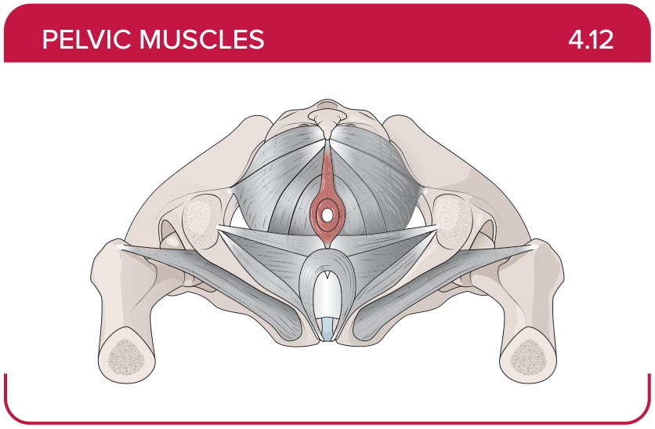
Title: External anal sphincter
Activity Interaction: select all that apply
Back-of-Card Content:
Proximal insertion:
- *anococcygeal ligament
- pubic symphysis
- ischial spine

Distal insertion:
- *perineal body
- pubic symphysis
- coccyx

Innervation:
- *pudendal nerve
- anterior rami of spinal nerves S4-S5

Action:
- *closes the anus
- voluntarily compresses urethra during urination
- stabilizes the coccyx

Card ID: 4.13
Image file: L1344_760112
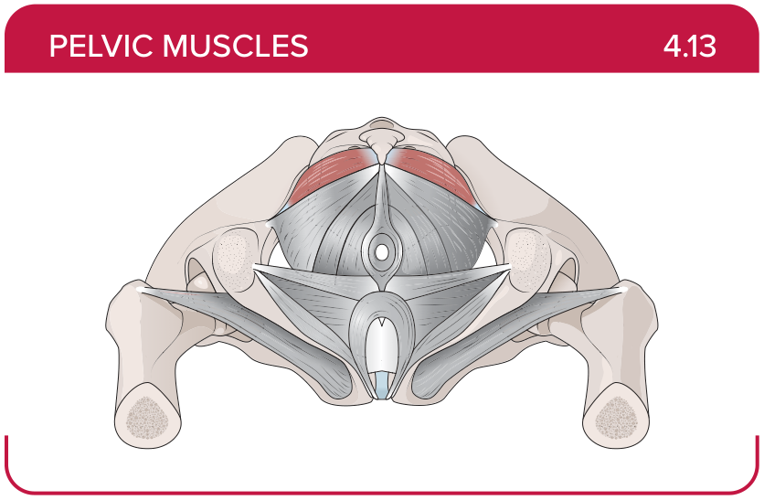
Title: Coccygeus
Activity Interaction: select all that apply
Back-of-Card Content:
Proximal insertion:
- *ischial spine
- ischial rami
- pubic rami
- ischium
Distal insertion:
- *anterior rami of spinal nerves S4-S5
- perineal body
- pubic symphysis
- coccyx

Innervation:
- *S4 and S5
- pudendal nerve

Action:
- *supports the pelvic floor
- *stabilizes the coccyx
- closes the anus

